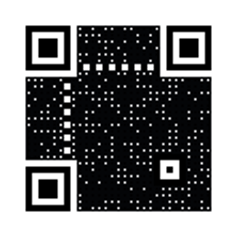 Yash